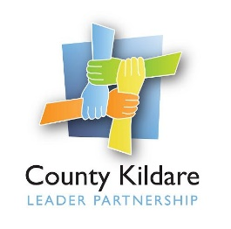
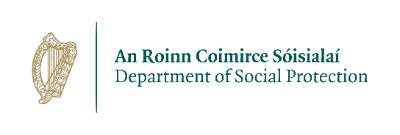

Advertisement
Supervisor DARA Project
(Drug Rehabilitation CE Supervisor)

County Kildare LEADER Partnership is a Local Development Company which acts as a sponsor for a Drug Rehabilitation Community Employment Scheme funded by the Department of Social Protection. The DARA Project is based in Athy and Kildare Town and is expanding its range of services to add a stabilization programme in Kildare Town to its existing drug free day programme.
We are seeking a Supervisor who will be responsible for the supervision of participants on the new stabilization programme and for assisting in the management and administration of the DARA Project CE scheme.
DARA Project CE Supervisor: The successful candidate will have a minimum Level 6 qualification and previous experience of working in a similar capacity. They will also have excellent interpersonal and communication skills, excellent administration skills and have an ability to work on their own initiative. CE Supervisor training would be desirable.
Salary will be on the CE Supervisor scale.
This is a full-time position (39 hours) with a fixed term twelve-month contract.
A copy of the job description is available at www.countykildarelp.ie or by email: liz@countykildarelp.ie
Application by CV only to liz@countykildarelp.ie

Closing date for receipt of applications: Wednesday 2nd October 2024 at 5pm.

County Kildare LEADER Partnership is an Equal Opportunities Employer.

