**Rural Development LEADER Programme 2014 -2020**

**Acknowledgement Signage**

In line with the Rural Development Programme Operating Rules, grant recipients must display acknowledgement signage highlighting the LEADER funding received at a location readily visible to the public, such as the entrance area of a building.

*This cost can be included in your application as an eligible project cost.*

**What type of Sign do we need?**

LEADER funding exceeds **€10,000**: At least one **weatherproof sign** with information about the operation (minimum size A3)

LEADER funding exceeds **€50,000:** At least one **weatherproof explanatory plaque** with information about the operation (minimum size A3)

**What information should the sign contain?**

Acknowledgement

*“This project received grant aid from Kildare Local Community Development Committee and support from County Kildare LEADER Partnership financed by the Irish Government under the Rural Development Programme 2014-2020 and by the European Agricultural Fund for Rural Development: Europe investing in rural areas.”*

An Irish translation* of above acknowledgement text must be included.

*“Fuair an tionscadal seo cúnamh deontais ó Chiste Forbartha Pobail Áitiúil Chill Dara agus tacaíocht ó Chomhpháirtíocht LEADER Chill Dara, á maoiniú ag Rialtas na hÉireann faoin gClár Forbartha Tuaithe 2014-2020 agus ag an gCiste Eorpach Talmhaíochta um Fhorbairt Tuaithe: An Eoraip ag infheistiú i gCeantair tuaithe.”*

Project Description

A description of the project (up to 50 words). An Irish translation* of the above project description must be included.

Logos*

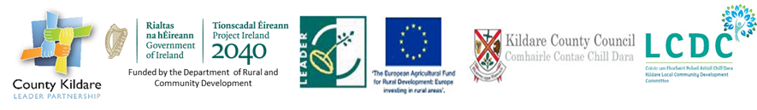

***\*Logos and translations can be obtained from County Kildare LEADER Partnership***

***at the time of ordering your plaque or sign. If you have any queries, please contact us.***

We have sent the specification to three local companies who can provide plaques or signs.

While the specification is the same with all companies, each company offers different finishes & materials ranging from Vinyl, Dibond Plastic, to Acrylic Panel. It is at each promoters’ discretion to choose the finish that best suits the area where the sign will be displayed.

The cost varies from €65.00 + VAT to a Premium Panel at €135.20 + VAT.

|  |  |  |
| --- | --- | --- |
| **Allen Sign & Print,**  Naas Industrial Estate,  Naas,  Co. Kildare  045 874815  allensignanddisplay@gmail.com  Graham Allen | **Donovan Printing,**  Units 16/18 Tarmel Centre,  Cutlery Road,  Newbridge,  Co. Kildare  045 433 874  [eugene@donovanprinting.com](mailto:eugene@donovanprinting.com)  Eugene Donovan | **SignFX,**  Naas,  Co. Kildare    [045 880603](tel:045880603) [info@signfx.ie](mailto:info@signfx.ie)  Colm Monaghan |